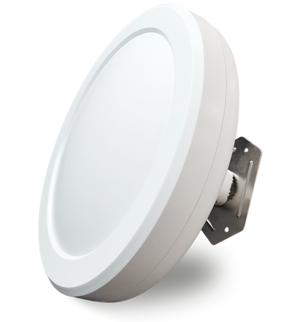
Product Features
- Digital display, one-click pairing, automatic connection, no setup required—simple and quick to use without a phone or computer.
- Supports peer-to-peer and point-to-multipoint bridging, offering flexible applications to meet diverse use cases.
- 5.8 GHz frequency band, supports spread spectrum technology with a maximum wireless transmission rate of 300 Mbps;
- Exhibits strong anti-interference capability, remains unaffected by external environmental factors, and ensures stable transmission;
- Equipped with Qualcomm's engineering-grade chips from the United States, delivering stable and reliable performance.
- Featuring a high-power circuit design with an integrated high-gain directional antenna, it delivers strong signal strength and extended transmission range.
- Supports automatic restart, reduces system operation cache, optimizes system performance, and ensures smooth long-term device operation.
- Supports hiding the bridging SSID from wireless signals to prevent wireless devices from detecting it, protect network data from malicious attacks, and ensure user data security.
- Supports both 24V PoE and 12V DC power supplies with plug-and-play functionality for flexible power sourcing.
- Featuring an outdoor rain-resistant design with IP65 protection rating, it is resistant to rain, dust, wind, and sunlight, effortlessly adapting to various harsh outdoor conditions while ensuring long-term stable operation.
- With an olive-shaped design that is simple yet elegant, it's easy to install and can be mounted either wall-mounted or on a bracket.
- Suitable for various outdoor application scenarios, including construction site monitoring, tower crane monitoring, scenic area monitoring, elevator monitoring, factory premises monitoring, port monitoring, residential community monitoring, and outdoor network transmission.
size of product
product name | 5.8G High-power Long-range Digital Wireless Bridge
product model | WB5830Y
Hardware Specifications
hardware system | Main Chip | AR9344
hardware system | internal storage | 64MB
hardware system | FLASH | 4MB
Wireless Parameters | protocol standard | IEEE 802.11a/n
Wireless Parameters | Working Frequency Band | 5.8G：5180MHz ~5825MHz
Wireless Parameters | Wireless Speed | 300Mbps
Wireless Parameters | transmitting power | 22dBm
physical interface | network interface | Two 10/100 Mbps Ethernet ports (both support 24V PoE power supply)
physical interface | Hardware Button | 1 digital button/RESET button
physical interface | Power Supply Interface | One DC power port, supporting 12V DC power supply
physical interface | Pull the switch | 1 pull-down switch (free switching between terminals A and B)
physical interface | Digital Display | 1 digital display (supporting 16 channels from 0 to 9, A to F)
Wireless Type | Wireless Type | Built-in 14 dBi bipolar directional antenna
pilot lamp | LED pilot lamp | In order: POWER, WAN/LAN, WAN/LAN, four signal lights, WIFI
Power Supply/Power Consumption | power supply mode | Supports DC 12V/1A power supply, 24V PoE power supply, and 48V PoE power supply
Power Supply/Power Consumption | Total Power of the Device | ﹤6W
Product Accessories | main engine | 5.8G High-power Long-range Digital Wireless Bridge Host *1
Product Accessories | Power Adapter | 24V 0.5A PoE power supply
Product Accessories | else | Stainless steel clamp *1  User Manual *1  Qualification Certificate *1
Appearance/Packaging/Weight | Appearance Color | white
Appearance/Packaging/Weight | product size | Φ200mm*131mm（Φ*H）
Appearance/Packaging/Weight | packing measurement | 313*238*73 mm
Appearance/Packaging/Weight | Weight per unit | 0.89KG
Appearance/Packaging/Weight | carton size | 495*385*333 mm
Appearance/Packaging/Weight | packing quantity | 10 pieces per box
Appearance/Packaging/Weight | net weight | 8.9KG
Appearance/Packaging/Weight | rough weight | 10.2KG
else | The optimal power supply distance for a PoE network cable | Within 65 meters (using Category 5e or higher network cables)
else | Bridge Distance | 0–3 km
else | IPC Load Capacity | Route 15: No lag, no delay
else | way to install | Rod mounting, Wall-mounted installation, Support bracket installation
else | levels of protection | IP65 rating; 2 kV lightning protection
Software Specifications
System Operation Mode | Normal Mode | This mode supports AP mode, client mode, and relay mode.  Support manual pairing bridging (in this mode, the digital display function is disabled)
System Operation Mode | Digital Display Mode | Auto-pairing supports one-click digital pairing without entering the web interface for manual pairing
Bridge Networking Method | Digital Pairing | Supports digital display and one-click pairing – convenient, simple, and fast
Bridge Networking Method | Manual Pairing | support
Bridge Networking Method | Point-to-point bridging | support
Bridge Networking Method | Point-to-multipoint bridging | support
network | work pattern | Wireless Bridge, AP Mode, Client Mode, Relay Mode
network | LAN Configuration | support
network | DHCP server | support
network | Wireless Network Status Display | support
Wireless Settings | SSID revise | support
Wireless Settings | SSID hide | support
Wireless Settings | way of encryption | WPA-PSK，WPA2-PSK
Wireless Settings | Bandwidth Settings | support
Wireless Settings | Wireless Channel Modification | Supports spread spectrum
Wireless Settings | Wireless User Isolation | support
Wireless Settings | Wireless Power Regulation | support
Wireless Settings | multi SSID | support
system management | Web interface management | support
system management | SL | Supports Chinese/English
system management | softdog | support
system management | Reset定时 restart | support
system management | user management | support
system management | firmware upgrade | support
system management | Firmware File Import and Export | support

interface specification
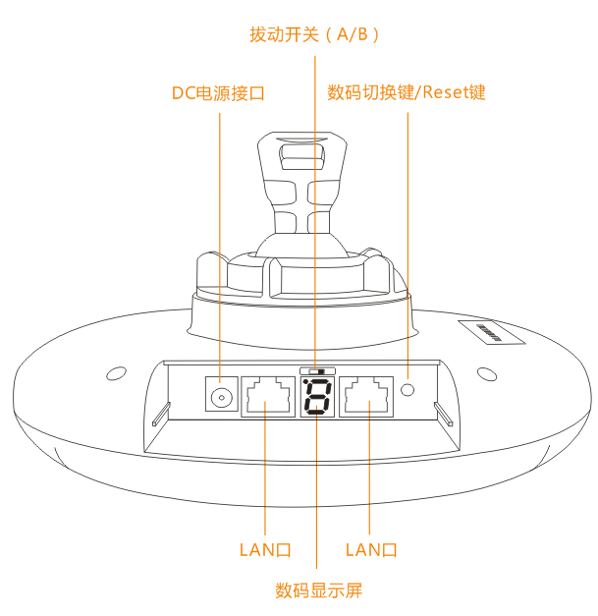
product size

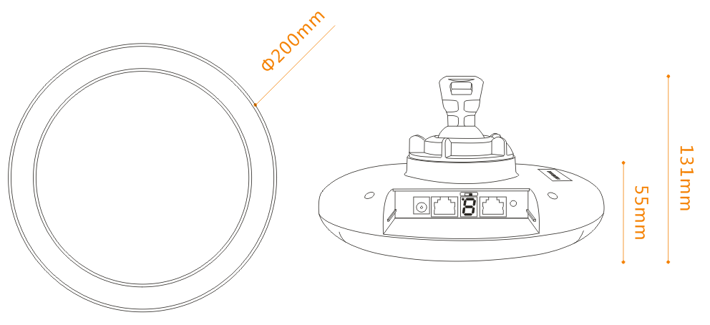

Product Application
I. Point-to-point wireless monitoring transmission applications 1

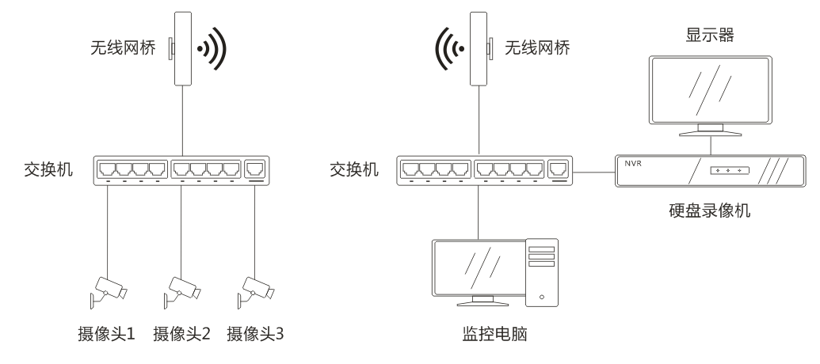

II. Point-to-point wireless monitoring transmission applications 2

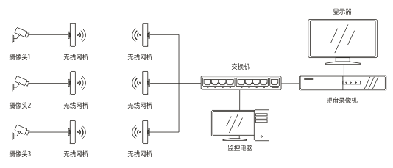

III. Wireless Monitoring Transmission: Point-to-Multipoint Applications 3

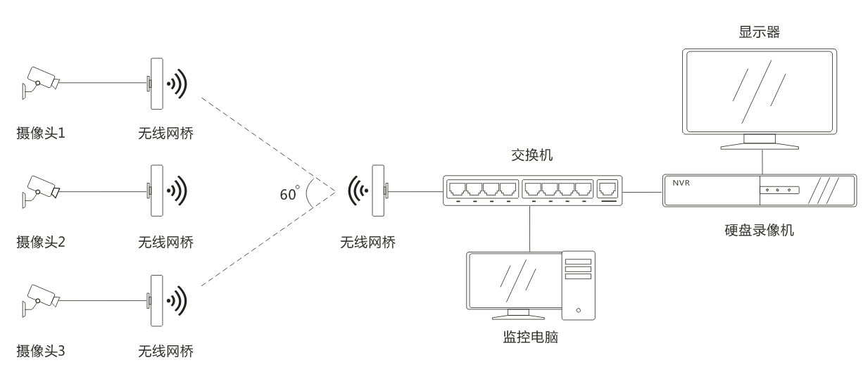

IV. Internet of Things Data Transmission Applications

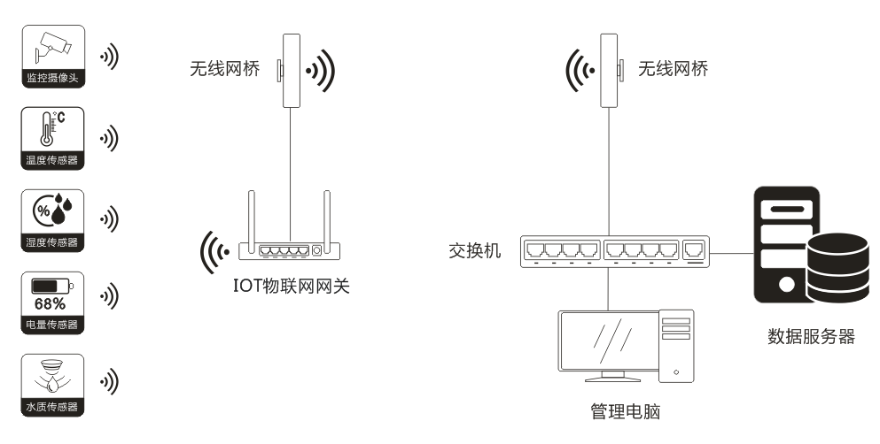

V. Applications of Wireless Data Transmission over the Internet 1

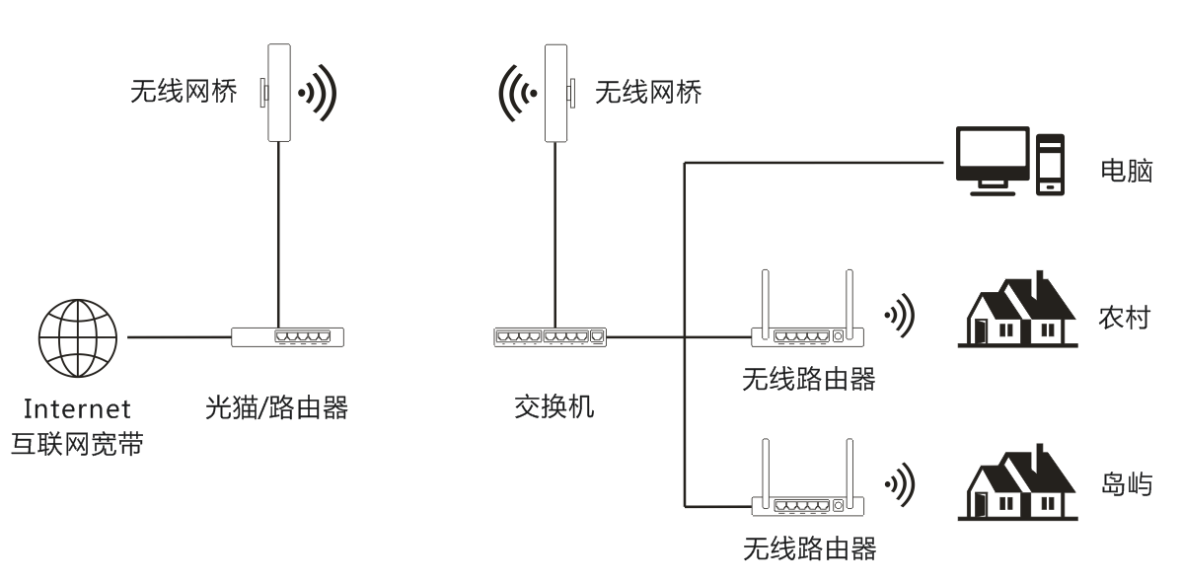

VI. Internet Wireless Transmission Applications 2
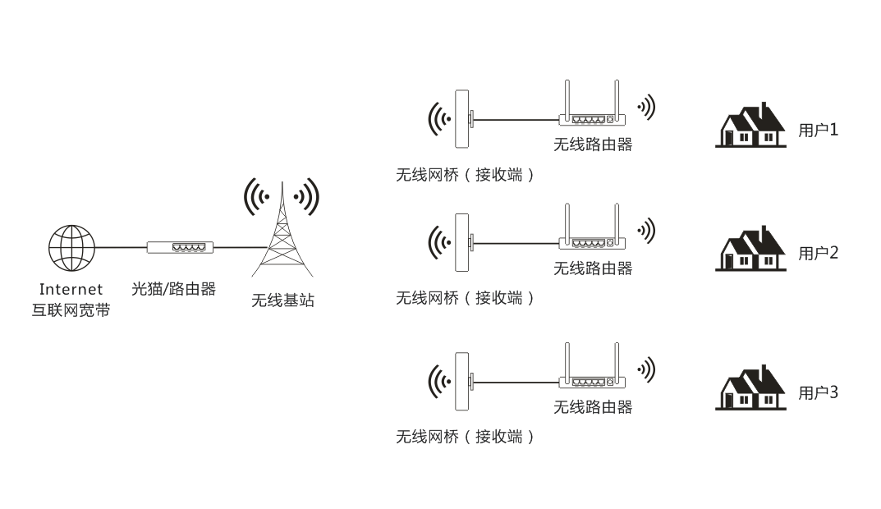

VII. Internet Coverage Applications 3

